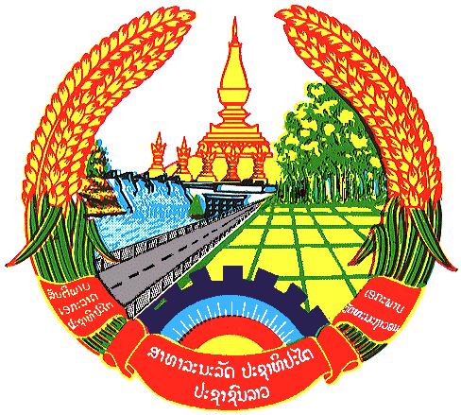

**Statement by the delegation of the Permanent Mission of the Lao PDR to the United Nations and other International Organizations in Geneva**

**at the 45th Session of UPR Working Group**

**Geneva, 26 January 2024**

(Speaking time 1.25 minute)

Review of the Central African Republic (9:00 - 12:30)

1. Thank you, Mr. President.
2. My delegation warmly welcomes the delegation of Central African Republic and thanks them for the presentation of the national report.
3. The Lao PDR commends the progress made by the Central African Republic in the promotion and protection of human rights in various areas in the country since the last UPR cycle. We welcome the adoption of the law on combating trafficking in persons, the law on the protection of children and many other legislations.
4. The Lao PDR would like to make 2 following recommendations:
5. **Continue efforts to strengthen the implementation of national law and strategic plan on combating trafficking in persons; and**
6. **Continue working to improve and expand health-care services.**
7. We wish the Central African Republic every success in this UPR cycle review.
8. I thank you, Mr. President.